**OS INSTALLATION**

**Windows11:**

Windows 11 is the latest operating system developed by Microsoft, succeeding Windows 10. Released in October 2021, it features a redesigned user interface with a centered Start menu, taskbar, and new window management features. Windows 11 also includes updates for gaming, virtual desktops, and improved support for touch, pen, and voice inputs..

**System Requirements:**

* Processor: 1 gigahertz (GHz) or faster with at least two cores.
* RAM: 4 gigabytes (GB) or more.
* Storage: 64 GB or larger storage device.
* System Firmware: Secure Boot capable.
* TPM (Trusted Platform Module): Version 2.0.
* Graphics Card: DirectX 12 compatible or integrated graphics with a WDDM 2.0 driver.
* Display: A display with at least 720p resolution that is greater than 9” diagonally, with 8 bits per color channel.

**Installation Process:**

Installing Windows 11 as a single operating system using a USB drive involves a series of steps.

**1)Preparing the USB drive:**

* **Downloading Windows 11 ISO:** Visiting the official Windows website and download the ISO file for the latest version.

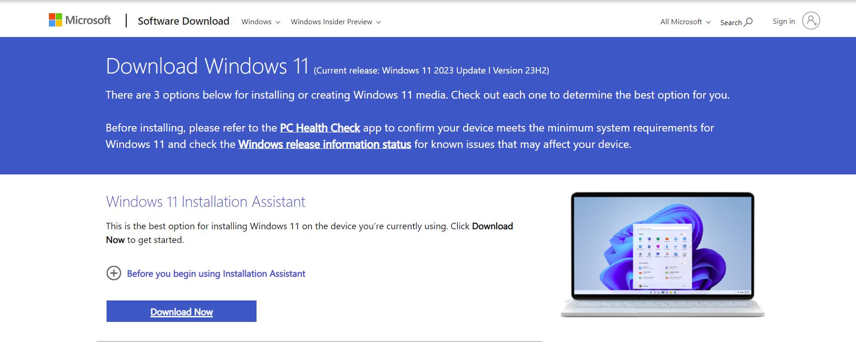

* **Creating a Bootable USB Drive:** Using tool Rufus to create a bootable USB drive. Following the instructions provided by the tool.
* Selecting the ISO File from the File manager.
* Press Start after configuring for the installation of Windows Operating Systems as per needs.

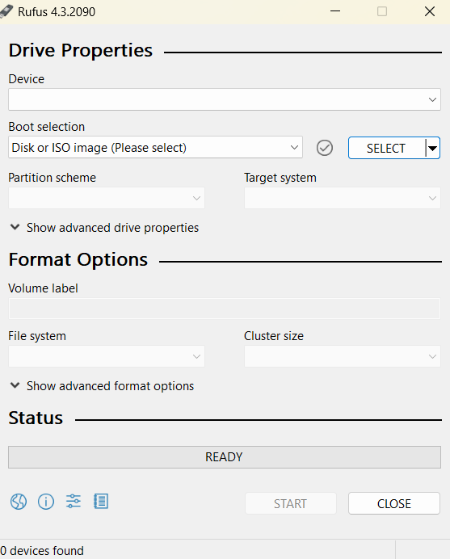

**2)Boot from the USB Drive:**

* **Insert USB Drive:** Plug the USB drive into a USB port on the target system.
* **Restarting the target system:** Restart the target system and during the boot process, pressing the esc key continuously to access the boot menu and F9 key to booting process.
* **Selecting USB drive:** In the boot menu, select the USB drive as the device to boot from which is San disk.

**3) Installing from Boot Pendrive:**

* **Insert Installation Media –** Insert the Windows installation USB or DVD into the computer.
* **Boot from Installation Media –** Restart the computer and boot from the installation media. This usually involves pressing a key (such as F2, F10, or DEL) during the startup process to access the boot menu and selecting the installation media.
* **Launch Windows Installer –** The Windows installer will automatically start. Follow the on-screen instructions to select language, time, and keyboard input.
* **Partitioning and Installation –** Choose the installation type. For a fresh installation, select the option to install Windows on the desired drive.
* Configure time zone and other regional settings.
* **Create User Account –** Set up a user account by providing a username and password.
* **Wait for Installation --** Allow the installer to copy files and complete the installation.
* **Complete the Installation –** Once the installation is complete, the system will restart.
* **Post-Installation –** Windows typically handles system updates automatically. You may need to connect to the internet to ensure the latest updates are installed**.**